# Angular: Paginated Football Competitions

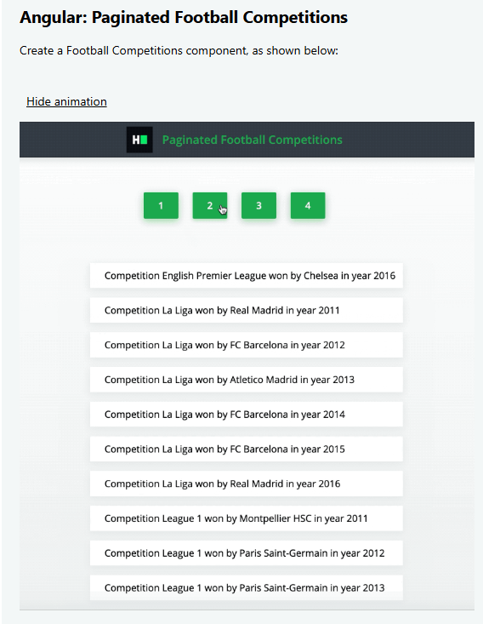

## footballCompetitions.component.ts

import { Component, OnInit } from '@angular/core';

import { HttpClient } from '@angular/common/http';

interface Competition {

  name: string;

  country: string;

  year: number;

  winner: string;

  runnerup: string;

}

interface ApiResponse {

  page: number;

  per_page: number;

  total: number;

  total_pages: number;

  data: Competition[];

}

@Component({

  selector: 'football-competitions',

  templateUrl: './footballCompetitions.component.html',

  styleUrls: ['./footballCompetitions.component.scss']

})

export class FootballCompetitions implements OnInit {

  totalPages: number = 0;

  competitions: Competition[] = [];

  constructor(private http: HttpClient) {}

  ngOnInit() {

    this.fetchPage(1);

  }

  fetchPage(page: number): void {

    const url = `https://jsonmock.hackerrank.com/api/football_competitions?page=${page}`;

    this.http.get<ApiResponse>(url).subscribe((response) => {

      this.totalPages = response.total_pages;

      this.competitions = response.data;

    });

  }

}

## footballCompetitions.component.html

<div class="layout-column align-items-center mt-50">

  <section class="layout-row align-items-center justify-content-center" data-test-id="page-number-buttons">

    <button *ngFor="let page of [].constructor(totalPages); let i = index" (click)="fetchPage(i + 1)">

      {{ i + 1 }}

    </button>

  </section>

  <ul class="mt-50 styled" data-test-id="football-competitions">

    <li class="slide-up-fade-in py-10" *ngFor="let competition of competitions">

      Competition {{ competition.name }} won by {{ competition.winner }} in year {{ competition.year }}

    </li>

  </ul>

</div>

# Angular: Length Converter

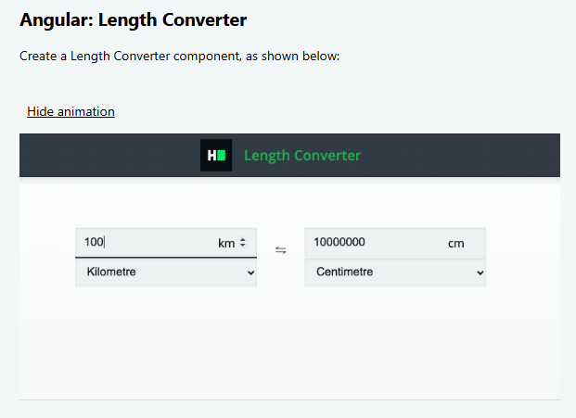

## lengthConverter.component.ts

import { Component, OnInit } from '@angular/core';

@Component({

  selector: 'length-converter',

  templateUrl: './lengthConverter.component.html',

  styleUrls: ['./lengthConverter.component.scss']

})

export class LengthConverter implements OnInit {

  lengthOptions = [

    { id: 0, label: 'Kilometre', unit: 'km' },

    { id: 1, label: 'Metre', unit: 'm' },

    { id: 2, label: 'Centimetre', unit: 'cm' }

  ];

  value1: number | null = null;

  value2: number | null = null;

  selected1 = this.lengthOptions[0]; // Default: Kilometre

  selected2 = this.lengthOptions[1]; // Default: Metre

  conversionMap: any = {

    km: 100000,

    m: 100,

    cm: 1

  };

  ngOnInit() {}

  onInput1Change(val: string) {

    this.value1 = +val;

    this.value2 = this.convert(this.value1, this.selected1.unit, this.selected2.unit);

  }

  onInput2Change(val: string) {

    this.value2 = +val;

    this.value1 = this.convert(this.value2, this.selected2.unit, this.selected1.unit);

  }

  onSelect1Change(id: number) {

    this.selected1 = this.lengthOptions.find(opt => opt.id === +id)!;

    if (this.value1 !== null) {

      this.value2 = this.convert(this.value1, this.selected1.unit, this.selected2.unit);

    }

  }

  onSelect2Change(id: number) {

    this.selected2 = this.lengthOptions.find(opt => opt.id === +id)!;

    if (this.value2 !== null) {

      this.value1 = this.convert(this.value2, this.selected2.unit, this.selected1.unit);

    }

  }

  convert(value: number, from: string, to: string): number {

    const base = value * this.conversionMap[from]; // Convert to cm

    return base / this.conversionMap[to];          // Convert from cm to target unit

  }

}

## lengthConverter.component.html

<div class="layout-row align-items-center justify-content-center mt-50">

  <section class="layout-column align-items-center justify-content-between">

    <span class="input layout-row">

      <input

        type="number"

        class="large"

        data-test-id="app-input1"

        [value]="value1 || ''"

        (input)="onInput1Change($event.target.value)"

      />

      <label class="suffix" data-test-id="app-label1">{{ selected1.unit }}</label>

    </span>

    <select data-test-id="app-select1" (change)="onSelect1Change($event.target.value)">

      <option *ngFor="let opt of lengthOptions" [value]="opt.id" [selected]="opt.id === selected1.id">

        {{ opt.label }}

      </option>

    </select>

  </section>

  <label>⇋</label>

  <section class="layout-column align-items-center justify-content-between">

    <span class="input layout-row">

      <input

        type="number"

        class="large"

        data-test-id="app-input2"

        [value]="value2 || ''"

        (input)="onInput2Change($event.target.value)"

      />

      <label class="suffix" data-test-id="app-label2">{{ selected2.unit }}</label>

    </span>

    <select data-test-id="app-select2" (change)="onSelect2Change($event.target.value)">

      <option *ngFor="let opt of lengthOptions" [value]="opt.id" [selected]="opt.id === selected2.id">

        {{ opt.label }}

      </option>

    </select>

  </section>

</div>